Functional and Non-functional Requirements (FR and NFR)
FR
- Customers:
  - can see the price of an item
  - add items to cart and modify quantity
  - choose delivery or location options along with available time slots
  - schedule recurring orders
  - choose a delivery location
  - cancel orders within an allowed window
  - view order history
- Producers:
  - create, edit and remove products
  - manage stock levels
  - view incoming orders
  - set or adjust prices
- Admin
  - create/manage user accounts, and assign roles and permissions to accounts
  - manage and reschedule orders
  - create/manage loyalty programs
  - log audit trails
- System
  - users can register and log in
  - passwords are processed securely using encryption
  - response times should be kept under a second
  - provide accessible UI compatible with WCAG
  - navigation bar will be displayed to all users

NFR

- Performance
  - website will load pages within 3 seconds
  - website will support multiple users at a time
- security
  - user data will be stored securely
  - the system will use a secure login authentication
  - the website will comply with UK GDPA and DPA 2018
- usability
  - the website will be easy to navigate and user-friendly
  - product info will be clear and easy to understand
  - users should be able to complete orders with minimal steps
- accessibility
  - the website will be accessible to users with disabilities
  - it will follow accessibility guidelines (good colour contrast and screen reader compatibility)
  - compliance with the equality act 2010
- reliability
  - available most of the time with minimal downtime
  - orders and data should not be lost if an error occurs

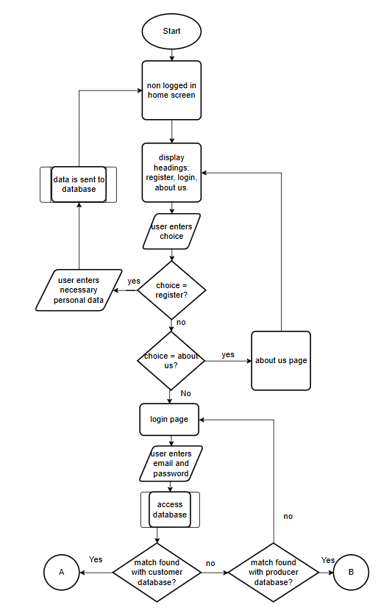
Decomposition
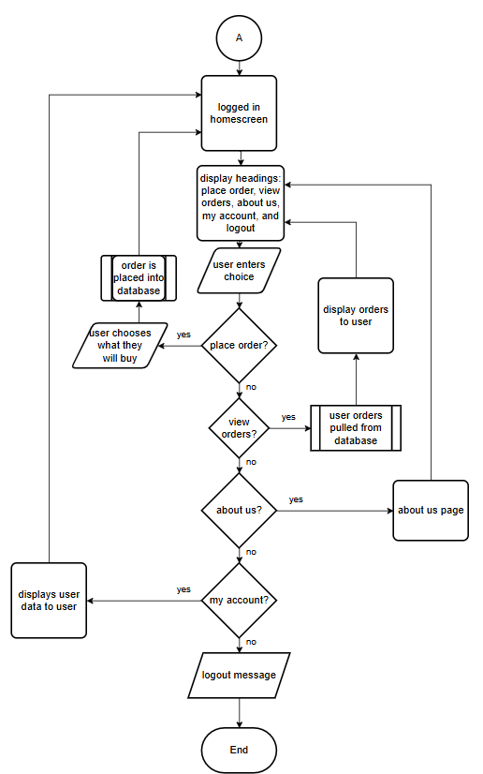

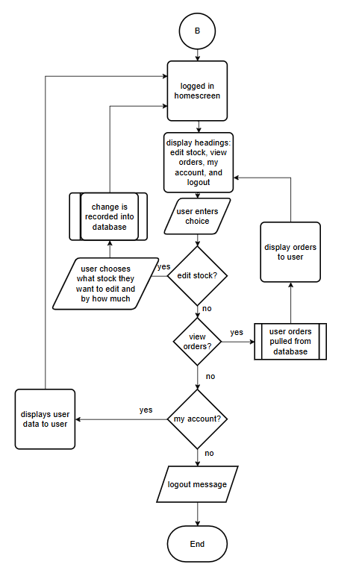
Decomposition Justifications
- user will start non logged in to begin with so therefore they will have a different homepage to logged in users there are some website functions that require the user to log in.
- the navigation bar will then display all the options they can choose from, fulfilling FR 4.5. hopefully these options will be clear and concise, partially fulfilling NFR 3.1
- the user can then click on a section they want to choose, this said page should load quick enough to meet NFR 1.1
- If the user chose register, then they will enter in their details depending if they are registering as a customer or producer and then this data will be stored in the database - FR 4.1, and the password will be encrypted using sha256 – FR 4.2
- If the user chose about us, then the website will provide information about the producers, their methods and the benefits of buying locally.
- If the user didn’t chose either of these two then they chose login as that it the only option left. The user will enter their email and password, that is on the system, and then they will be logged on.
  - If they log on as a customer then their new headings will be: place order, view orders, about us, my account and logout
  - If the user logs on as a producer their new headings will be: edit stock, view orders, my account, logout
- these user will still click on the navbar to go to the intended page and that page will perform its intended function
- the flowcharts will only end when the user has chosen to logout.

Entity Relationship (ER) Diagram
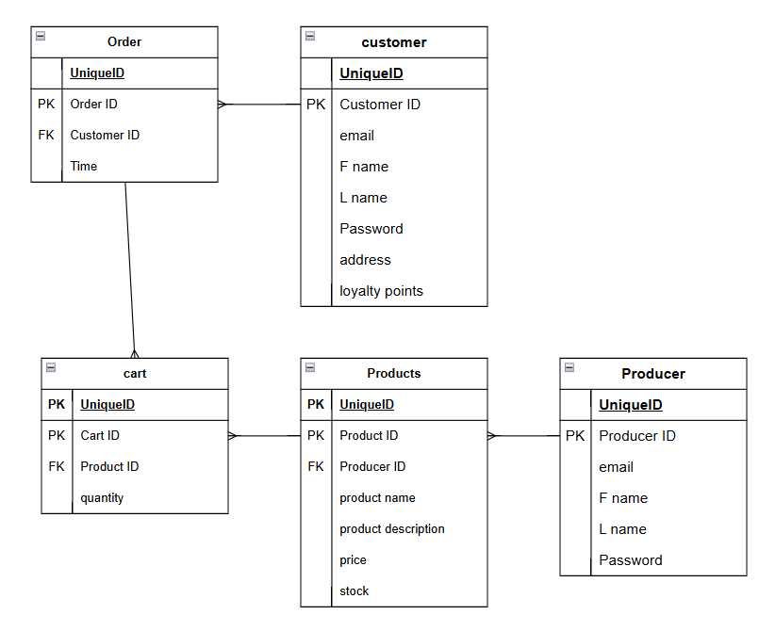
this is what the ER diagram looks like.
Justifications:
- A customer can have many orders but an order can only have one customer so it is a one to many relationship.
- And order can have many products and products can have many orders so I have created a cart entity that will co
- The order table has customer ID as a foreign key so that we can find both the customer easily from the order.
- a producer can have many orders but an order can only have one producer, so it is also a one to many relationship.
- Each entity has been assigned an ID so that the rest of the information will be easy to find if we know the ID.

Data Flow diagram
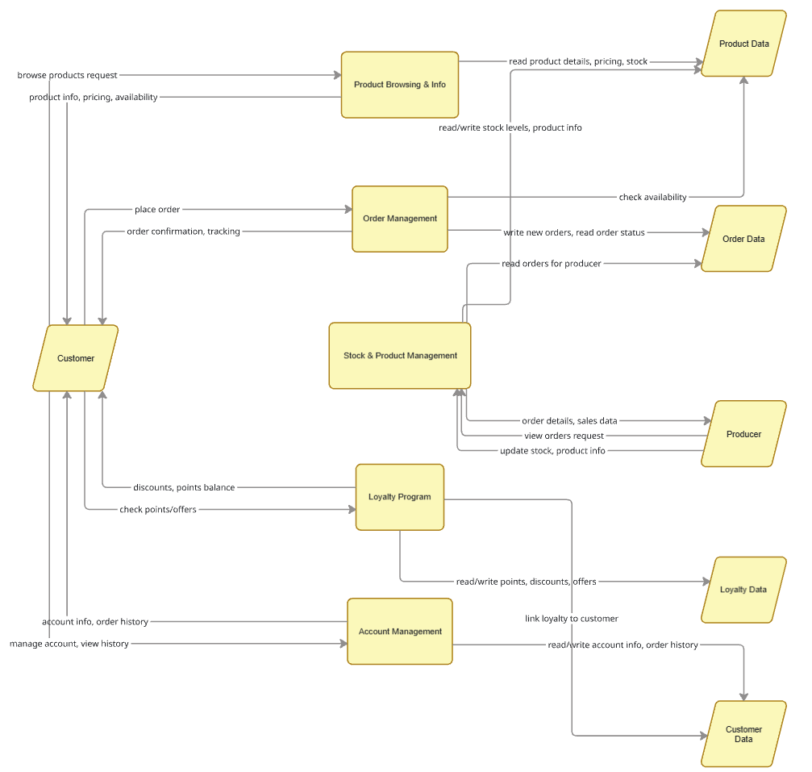
Justifications:
Processes
Product browsing and information
- allows customers to view detailed product information, like pricing, availability etc
- essential for transparency and informed purchasing, aligning with GLH’s idea of being open about producers and their products
- will require the product data in order to receive the information, will then provide customers with the product information on requesting
Order Management
- required to allow customers to place orders for collection or delivery.
- Reads and writes orders from order data
- will send order confirmation back to customers
- checks product availability from product data to validate orders
Stock and product management
- allows producers to update product details and stock levels and to view orders
- provides producer dashboard that is required for managing inventory and sales
- reads the order data that producers will have to supply
- updates the stock in product data
- recieves requests from producers to view orders and update stock/product information
loyalty program
- manages loyalty points, discounts and special offers
- is the implementation of the loyalty scheme GLH has asked for
- reads and writes loyalty points and discounts from loyalty data
Data stores
Product data – stores product descriptions, pricing, and stock levels, used both by producers and customers
Order data – holds details of placed orders, when they were placed for, whether they are delivery or pickup. These are also used by producer and customers
Customer data – contains customer accounts and their order history, used by account management and loyalty data.
Loyalty data – stores loyalty points and discounts, enabling the loyalty program to function
User Summary
customers send browse request to receive product info, place orders and receive confirmation, check loyalty points and discounts, and manage account information and order history
producers update stock and product info, view order details and receive sales through the dashboard

Data dictionary
Variable name | Data type | Description | Example data | Reasoning
Customer_ID | integer | Unique identifier for each customer account | 4 | Allows system to identify each customer easily
Producer_ID | Integer | Unique identifier for each producer account | 4 | Allows system to identify each producer easily
F_name | String | First name of user | Bob | To personalise each account
S_name | String | Last name of user | Smith | To personalise each account
Email | String | User’s email address | bobsmith@gmail.com | Used for account login
Password | string | User’s password, will be stored using sha 256 to keep it secure and comply with FR 4.2 | Passw0rd! | Adds security to account login
Address | String | Default delivery address | 10 Market Street, Leeds | Required for giving orders to customers
Loyalty points | Integer | Points gained from loyalty system | 50 | Required for the loyalty rewards system to work
Product ID | Integer | Unique identifier for each product | 4 | Allows system to identify product
Product name | String | Name of product | Eggs | Allows customers to identify product
Product description | String | Description of the product | The eggs are from free range chickens | Provides customer with detailed product info
Price | Float | Price of product | 2.50 | Display the price to customers
Stock | Integer | Quantity of product available | 20 | Allows system to track product availability
Order ID | Integer | Order identifier | 4 | Allows orders to be tracked
Quantity | Integer | Quantity of item ordered | 1 | To show how many units of product were purchased

Colour scheme
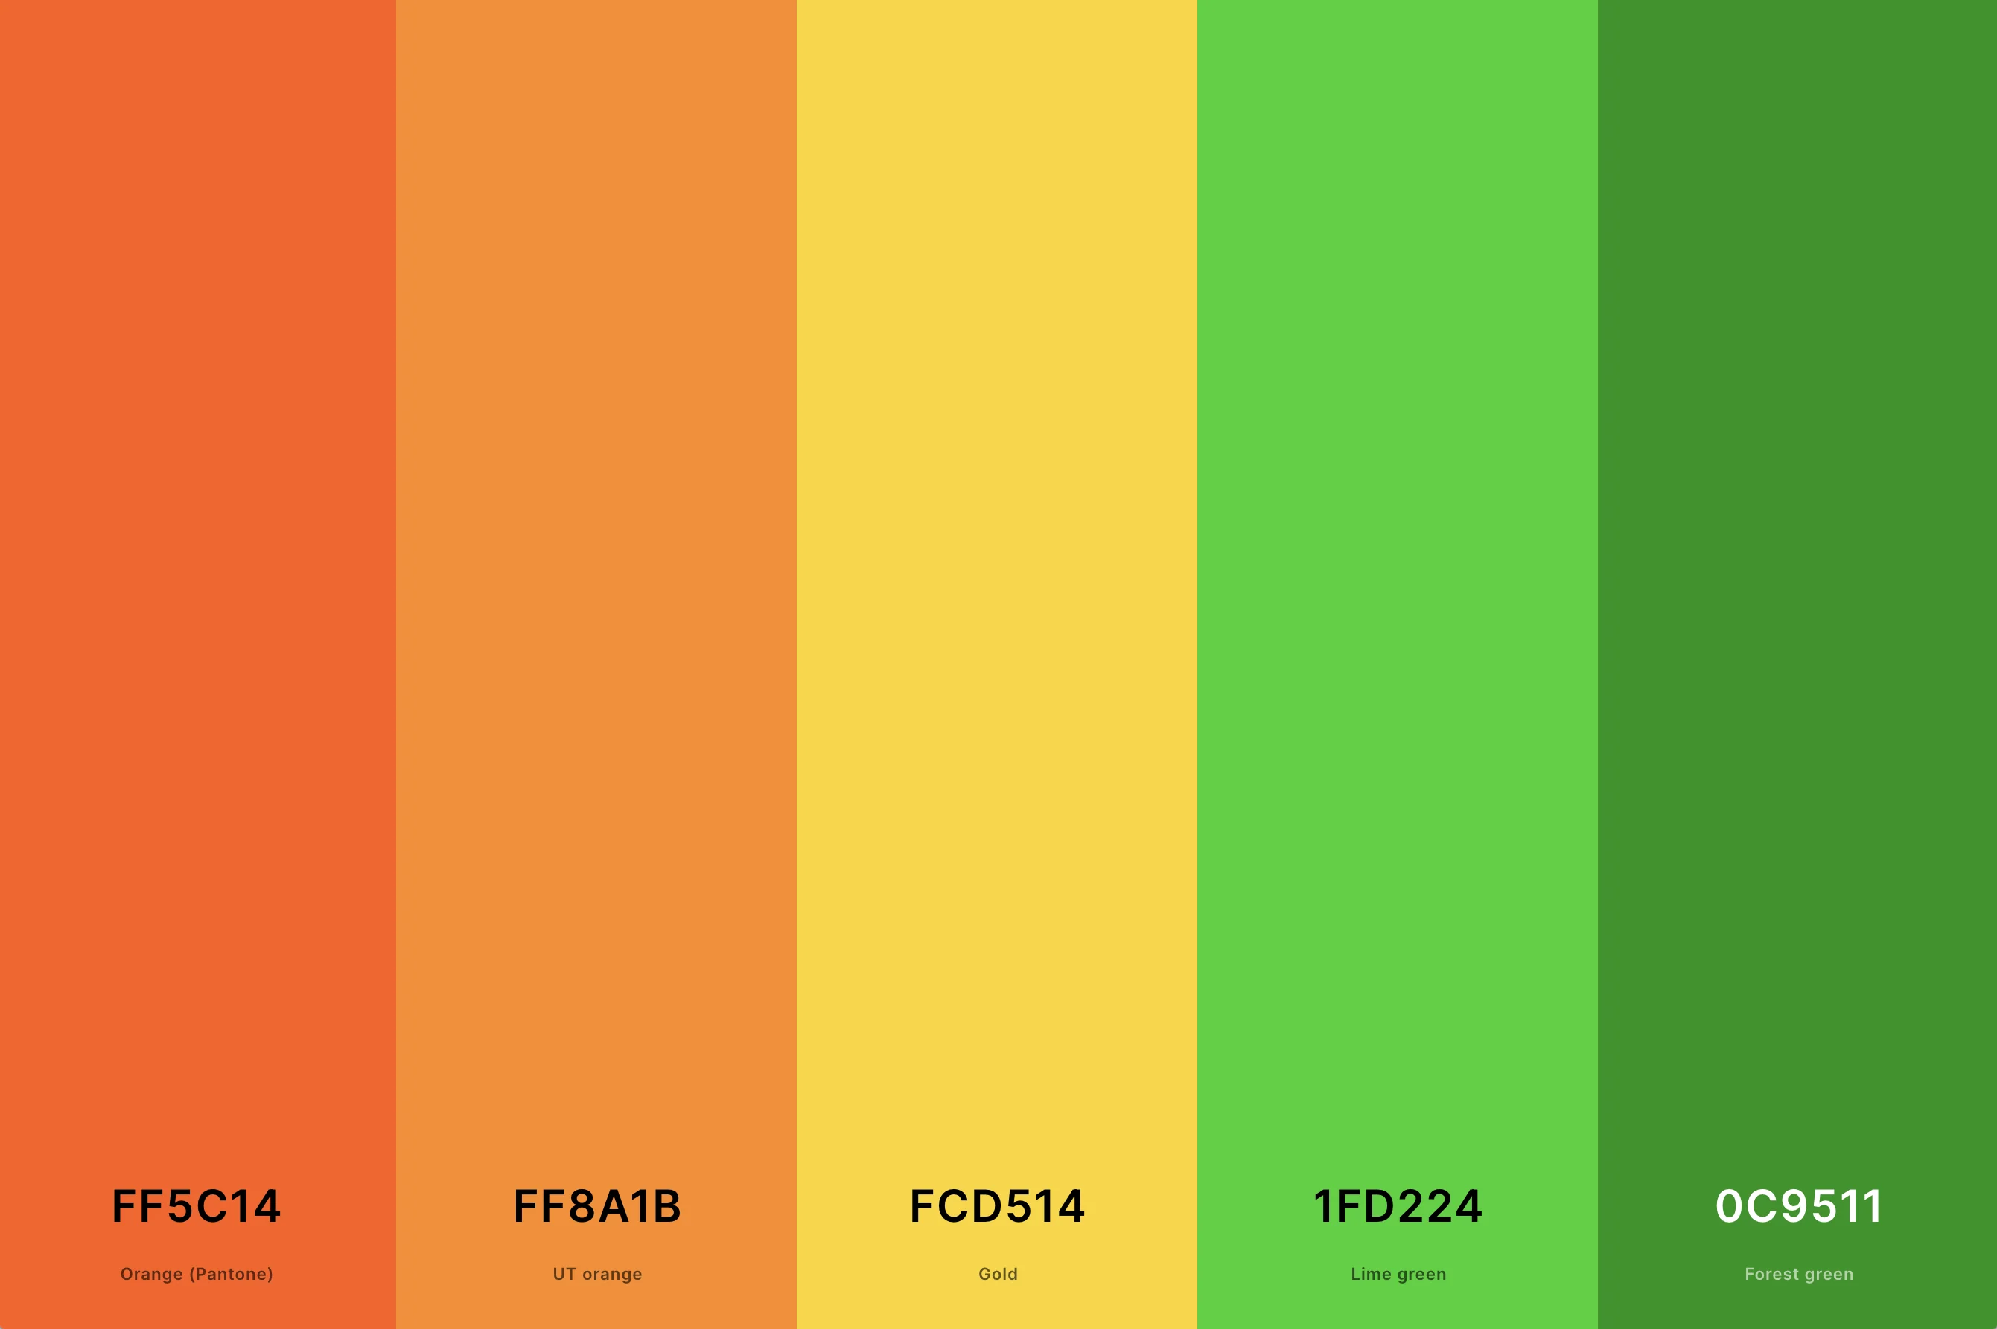
These are the colours I will be using, I have chosen this palette as the colours are contrasting, making reading much easier and meeting the criteria of NFR 4.2. The green is associated with nature, farming, freshness and sustainable. Since GLH is a cooperative of local farmers and food producers, green should reinforce the idea of local, natural and sustainable food. The orange makes up a good secondary colour as it represents friendliness and community, these reinforce the idea of supporting local producers and community based shopping. It also, like green, gives food imagery, further supporting the ideas of GLH.

Interface design
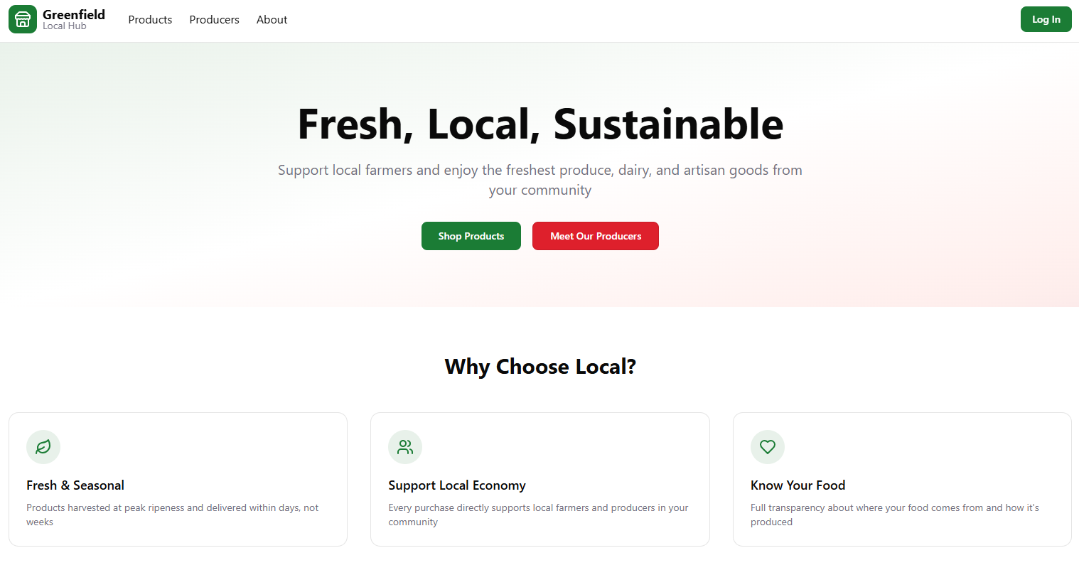
Justifications:
I have chosen to make my buttons coloured so that users can identify them
The buttons are coloured green and red due to my colour scheme being primarily consistent of those two colours.
The navbar is at the top so that users can navigate easily but also explore the page they are on without inconvience

Pseudocode
Connect to database
FUNCTION connectToDatabase(connectionParameters)
TRY
connection = openDatabaseConnection(connectionParameters)
IF connection IS successful THEN
RETURN connection
ELSE
THROW "ConnectionFailedError"
CATCH error
DISPLAY "Database connection error: " + error.message
RETURN null
END FUNCTION

Insert into database

FUNCTION insertData(connection, tableName, data)
TRY
query = buildInsertQuery(tableName, data) // e.g., "INSERT INTO tableName (fields) VALUES (values)"
result = executeQuery(connection, query)
IF result IS success THEN
RETURN true
ELSE
THROW "InsertFailedError"
CATCH error
DISPLAY "Insert error: " + error.message
RETURN false
END FUNCTION

Get data into database

FUNCTION getData(connection, tableName, filterCriteria)
TRY
query = buildSelectQuery(tableName, filterCriteria) // e.g., "SELECT * FROM tableName WHERE conditions"
results = executeQuery(connection, query)
RETURN results // Could be a list of records or empty if none found
CATCH error
DISPLAY "Data retrieval error: " + error.message
RETURN null
END FUNCTION

Process data from the database

FUNCTION processDataFromDatabase(data)
IF data IS null OR data IS empty THEN
DISPLAY "No data to process"
RETURN null
END IF
processedData = initializeEmptyStructure()
FOR EACH record IN data DO
processedRecord = processSingleRecord(record) // e.g., calculate fields, format values
ADD processedRecord TO processedData
END FOR
RETURN processedData
END FUNCTION

process data from input

FUNCTION processDataFromInput(rawInput)
cleanedInput = validateAndSanitize(rawInput)
IF cleanedInput IS invalid THEN
DISPLAY "Invalid input data"
RETURN null
END IF
processedInput = transformInput(cleanedInput) // e.g., parsing, data type conversions, enrichment
RETURN processedInput
END FUNCTION
test strategy
This part of the design document is a separate file due to formatting issues

